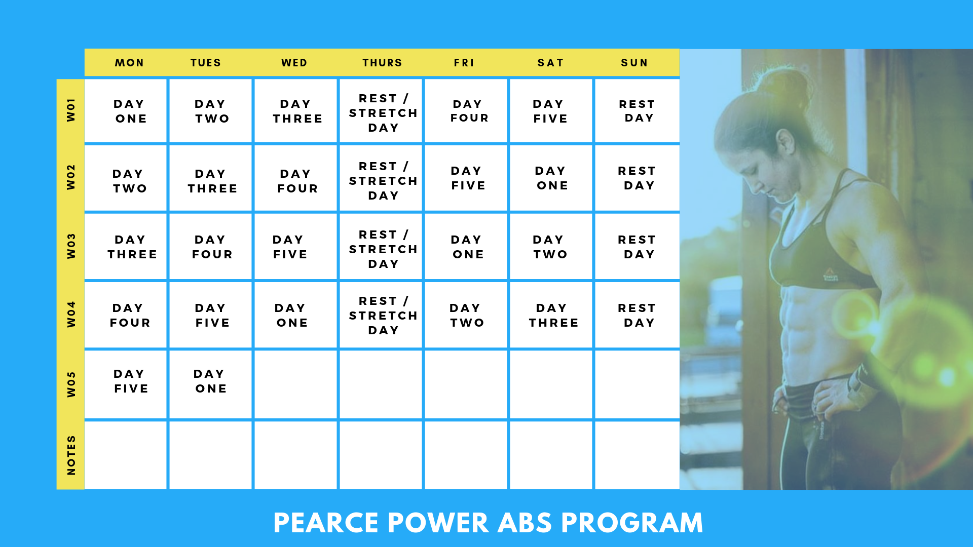
Lesson 1: Before You Start
Some important things to keep in mind before we start...

- You can do this workout anywhere you have access to a floor. No equipment is necessary!

- Nutrition for these next 30 days is important! Try to eat clean, and stay hydrated. Hydration is key!

Each day, I will introduce the movements we will be doing in our workout. Follow the technique closely to ensure you get the maximum benefit of the exercise.

Mountain Climbers
1. Start in a push-up position.
2. Bring one knee into your chest.
3. Keep your core nice and tight.
4. Shoulders are engaged.
5. Alternate bringing your knees in to your chest.
6. Start slowly and increase speed as you become more comfortable.
7. To modify if you are not quite flexible yet, bring your knee in to just under your hips or however far is comfortable.

Hollow Body Hold
This is the single most important foundation movement to improve your gymnastics and take your training to the next level.
This may look simple, but believe me - if you are doing this correctly, it is much harder than it looks!

1. Start on the floor, lying flat on your back.
2. Extend your arms over your head.
3. Straighten your legs out.
4. Eyes up towards the ceiling.
5. Lift your shoulders and legs up, keeping your back firmly pressed to the floor. There should be no space between your lower back and the ground!
6. Keep core tight in the Hollow Body position.
7. To modify this position to keep your back firmly pressed against the ground, bring your knees in to a bent position.

As you become more comfortable in that modified position, slowly work on extending your arms and legs to the original Hollow Body position.

Plank Hold
1. Start on the floor, on your elbow and toes.
2. Your shoulders should be directly above your elbows.
3. Hands relaxed.
4. Head Neutral. Core is tight.
5. You should be in a nice straight line from your shoulders to your core, to your heels.
6. Be aware of your hips, do not raise them up or dip them down. Stay in a straight line.
7. Abs engaged and bottom squeezed tight for support.

Plank Walk Up -
If you have mastered the Plank, this is your Level Two movement
1. Start in the plank position on your elbows.
2. Walk up to your hands.
3. Go back down to your elbows.
4. Alternate which arm you start with for each rep to maintain the balance of each arm.
5. Core stays tight throughout.
6. Do not sag your hips.
7. Be sure you are getting all the way to a nice, extended plank position.

Superman’s (Arch Holds)
1. Lie on the floor, flat on your stomach
2. Raise your hands straight ahead keeping them by your ears.
3. Lift your arms and legs up at the same time.
4. Head remains neutral. Legs remain straight.
5. When you do this correctly you will be activating your shoulders, your lower back, your glutes, and your hamstrings. Also make sure you're pulling your hands up as high as you can!

Windshield Wipers
1. Start flat on your back, lying on the floor.
2. Arms extended out to the side. This will help you with your balance throughout the movement.
3. Leg position -
Level One - Legs stay bent 90 degrees throughout the movement
Level Two - Straighten your legs.
4. Moving at your waist, move your legs from one side to the other, as though you are a windshield wiper.
5. Stay slow and controlled throughout the movement. Do not let your feet or knees hit the ground throughout the movement. Decrease the range of motion if your feet are hitting the ground.

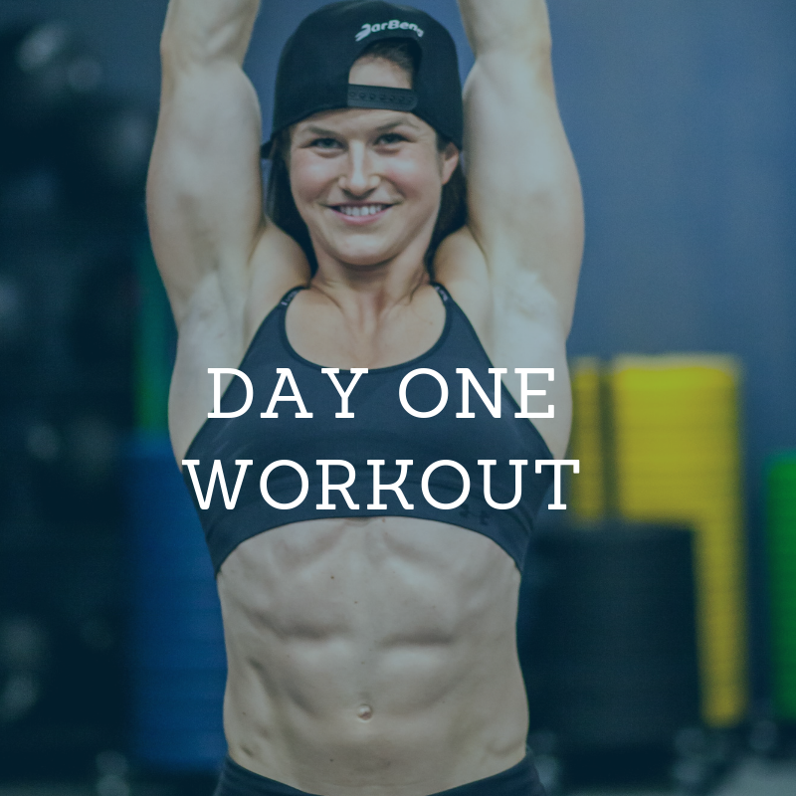

Lesson 1A: The Workout
2 Rounds for each level

Level 1
:30 on / :30 off
- Mountain Climbers
- Hollow Hold
- Plank Hold
- Superman’s
- Bent Knee Windshield Wipers

Level 2
:40 on / :20 off
- Mountain Climbers
- Hollow Hold
- Plank Walk Ups
- Superman’s
- Windshield Wipers

Share your progress with me on social on my Instagram, Facebook, or Twitter page or Send them to me at Kari@PearcePointers.com with the hashtag #PearceAbs. Good luck!

