Lesson 2: Introduction
Today we are going to work on another five movements to help strengthen and tighten your core. Remember to keep breathing throughout these exercises, as it is very easy to hold your breath when doing core work. Keep breathing to get the oxygen to your muscles.

Let's start with everyone's favorite exercise, Burpees!

Burpees
1. Start in a standing position
2. Get your hands as close to your feet as you drop down.
3. Drop to the floor so that your chest and thighs touch the floor.
4. Jump your feet in.
5. Stand Up.
6. Jump up with your arms above your head.

To modify this movement:
1. Place your hands on the ground.
2. Step one foot back, followed by the other foot.
3. Touch your chest and thighs to the ground.
4. Push yourself back up.
5. You can stand or jump up from this position.

To further modify, if necessary:
1. Place your hands on the ground in a push up position.
2. Briefly hold in a plank position.
3. Step your feet back in one at a time.
4. Stand up with your arms over your head to complete the movement.

The goal with any modification is to increase your strength to the point that you are doing the original movement as prescribed without any modification for full benefits of the exercise.

Tuck Ups - Level One movement
1. Start in the Hollow Body Position.
2. Bring your knees into your chest. Arms following through the movement.
3. Return to the Hollow Body Position with your arms over your head.
4. Note, when you are in the tuck position, you are sitting on your hips and not your back. Everything is engaged.

V Ups - Level Two movement
V-Ups are important because they are an extension of the hollow hold I taught you earlier to further build your core strength.

1. Start in the hollow hold position.
2. Keep your legs straight and bring your toes up, while at the same time lifting your upper body touching your fingers and toes together at the top forming a V with your body.
3. Your head stays straight with your chin tucked in.
4. After your toes and fingers touch at the top return back and repeat the movement.

Plank Walkouts
This movement is essentially the same for both Levels. The only difference is the degree in how far you walk your hands out.

1. Start in the push-up position on your hands.
2. Core is nice and engaged.
3. There should be a straight line from your shoulders, to your hips, to your heels.
4. Slowly walk your hands out.
5. Once you have walked your hands out, slowly walk them back in to your starting position.
6. If you feel your hips sag, limit the range of motion you are using.

The stronger you are, the farther out you will be able to walk your hands.

Reach Thrus (or as we used to call them in gymnastics, "penguins. You'll see why!)

1. Start flat on your back with your feet flat on the floor.
2. Lift your shoulders off of the floor, but keep your back flat to the ground.
3. Hands are hovering above the ground.
4. Tap one heel by leaning to the side.
5. Tap the other heel.
6. Continue to alternate, trying to get as close to your heel as you can.

You will feel your abs working here, particularly your obliques.

Seated Leg Lifts
Seated Leg Lifts to Strengthen Your Core and Hip Flexors.

1. Sit on the floor, back straight, legs straight out.
2. Place your fingertips on the ground. The further down your legs you place your fingers, the harder the exercise becomes.
3. Lift and then lightly tap one leg to the ground.
4. If this movement is too easy for you, you are a Level Two. For this exercise, you will lift both legs at the same time. Again, adjusting the placement of your hands further down your legs to increase difficulty within each variation.

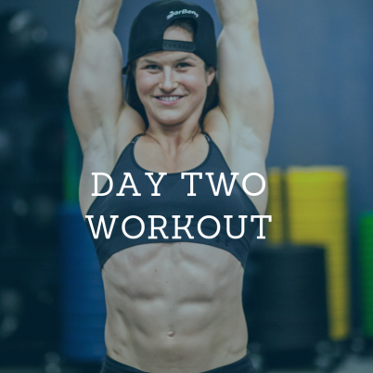
Lesson 2A: The Workout
9 MINUTE AMRAP (As Many Reps As Possible)

Level 1
- 10 Burpees
- 10 Tuck Ups
- 10 Plank Walkouts
- 10 Reach Thrus (each side)
- 10 Seated Single Leg Lifts (5 each side)

Level 2
- 10 Burpees
- 10 V-Ups
- 10 Plank Walkouts
- 10 Reach Thrus (each side)
- 10 Seated Leg Lifts

