Lesson 3: Introduction
We have four new exercises for you today to continue to give you that full core workout.

Rotating Plank
I like this one because it will hit your rectus abdominis, (your six pack muscles) and your obliques.
1. Start in the Plank position.
2. Core nice and tight. No sagging hips.
3. Straight line from your shoulders, to your hips, to your heels.
4. Rotate to one side.
5. Your feet will be stacked one on top of the other.
6. Your arm is lifted, with your elbow slightly bent.
7. You will maintain a straight line from the bottom of your shoulder, to your hips, to your heels.
8. Return to your starting position.
9. Repeat on the other side, alternating sides throughout the exercise.

To modify this movement, simply lower your knees to the ground. However, try to start this movement on your feet and scale down to your knees if you become tired.

Sit-Up Slides / V-Sit Slides
Level One will do the Sit-Up Slide
1. Lie on your back, knees bent.
2. Arms on your thighs.
3. Head neutral
4. Brace your abs, squeeze nice and tight.
5. Slide your hands up your knees, lifting your shoulders nice and high off of the ground.
6. Your back remains flat on the ground throughout. This is very important.

Level Two will do the V-Sit Slide
1. Lie on your back, legs extended in the air.
2. Arms on your thighs.
3. Head neutral
4. Brace your abs, squeeze nice and tight.
5. Slide your hands up your legs towards your ankles, lifting your shoulders nice and high off of the ground. for a greater range of motion.
6. Your back remains flat on the ground throughout. This is very important.

Crossbody Mountain Climbers
1. Start in a push-up position.
2. Bring one knee into your opposite elbow, across your chest.
3. Keep your core nice and tight.
4. Shoulders are engaged.
5. Alternate knees.
6. Start slowly and increase speed as you become more comfortable.
7. To modify if you are not quite flexible yet, bring your knee in to just under your hips or however far is comfortable.
8. Be conscious of the twisting motion you are doing with your body.
9. You should be in a nice flat line from your head, to your hips, to your heels.

Candlestick Roll to Sit-Up /Candlestick Roll to Jump
Level One will do the Candlestick Roll to Sit-Up
1. Starting in a seated position, Feet together, arms up by your ears, nice and straight.
2. Slowly lower yourself into the squat position. Get your butt as close to your heels as you can. This will help work your hip mobility.
3. Roll backwards, slowly.
4. As you roll onto your shoulders, extend your feet towards the ceiling. Keep your feet and legs glued together. Make sure that when you’re rolling back, your feet go straight up and not over your head
5. As you extend your feet up, keep your arms straight over your head in the original starting position. This creates the candlestick position.
6. Bring yourself back up to your original starting position, reaching forward to touch your toes.

Level Two will do the Candlestick Roll to Jump
1. Starting in a seated position, Feet together, arms up by your ears, nice and straight.
2. Slowly lower yourself into the squat position. Get your butt as close to your heels as you can. This will help work your hip mobility.
3. Roll backwards, slowly.
4. As you roll onto your shoulders, extend your feet towards the ceiling. Keep your feet and legs glued together. Make sure that when you’re rolling back, your feet go straight up and not over your head
5. As you extend your feet up, keep your arms straight over your head in the original starting position. This creates the candlestick position.
Bring yourself back up, by rolling forward. Bring your heels to your butt as quickly as possible. This will make the roll more efficient!
7. Jump up as you return to the starting position.

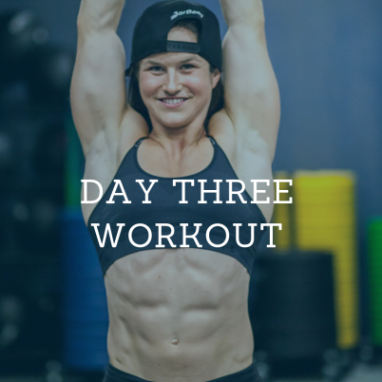
Lesson 3A: The Workout
Complete 3 rounds of each exercise before moving on to the next.

Level 1
:30 on/:15 off
- Rotating Planks
- Sit-Up Slides
- Crossbody Mountain Climbers
- Candlestick to Sit-Up

Level 2
:30 on/ :15 off
- Rotating Planks
- V-Sit Slides
- Crossbody Mountain Climbers
- Candlestick to Jump

