Lesson 4: Introduction
Flutter Kicks
1. Lay on your back in the Hollow Body position
2. Arms are extended over your head.
3. Back is flat against the ground.
4. Flutter your feet while maintaining the Hllow Body position.

To modify this movement, bring your arms down to the ground on either side of your legs.
Planche Press / Wall Walks
Level One will do the Planche Press
1. Start in a push-up position
2. Core is tight and engaged throughout the movement.
3. Lift hips up towards the sky, creating a straight line between your hips, to your shoulders, to your wrists.
4. Head remains neutral.
5. Lower back down into a push-up position.
6. Repeat.

Level Two will do Wall Walks
1. Start by lying flat on the ground, with your feet against a wall.
2. Push yourself up.
3. Take a big step up the wall.
4. Walk yourself slowly into the wall until your nose touches. The goal is to have your nose touch the wall without letting your legs touch.
5. Slowly walk yourself back down the wall to your starting position.

If you do not feel comfortable going all the way to the wall, modify the movement and walk as close as you feel comfortable doing.

Tap Crunches
1. Lie on your back with your knees bent.
2. Your hands are right behind your head, with your elbows out straight to the side.
3. Lift your shoulders and feet simultaneously, crunching in the middle.
4. Your back is flat against the ground and you are bracing your abs with each rep.
5. You will want to take a nice pause at the top of each crunch.

Floor Thrusters with Push-Up
A Floor Thruster is a half Burpee. You are jumping your feet in and back out again, with an added push-up.

1. Start in a push-up position.
2. Head neutral, core engaged.
3. Jump your feet in to behind your hands, as close as you can.
4. Your feet should be flat against the ground.
5. Jump your feet back to your starting position.
6. Do a push-up with your chest making contact with the floor.

To modify this movement, you can perform your push-ups on your knees instead of your toes.

Hollow to Arch Roll
1. Start in the Hollow Body Position. Flat on your back, arms over your head, legs raised off of the floor.
2. Slowly roll to the Arch Hold or Superman position.
3. Roll back to the Hollow Body Position.
4. Your feet and hands should not touch the floor throughout the exercise if at all possible.

Hollow to Rolling V-Up
1. Start in the Hollow Body Position. Flat on your back, arms over your head, legs raised off of the floor.
2. Do a V-Up
3. Slowly roll to the Arch Hold or Superman position.
4. Roll back to the Hollow Body Position.
5. Do a V-Up
6. Repeat.
7. Your feet and hands should not touch the floor throughout the exercise if at all possible.

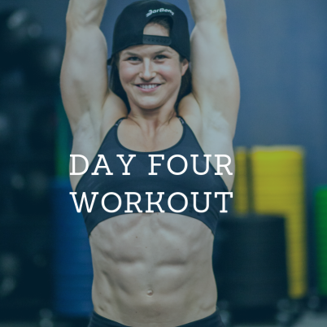
Lesson 4A: The Workout
2 Rounds

Level 1
:40 on / :20 off on each exercise
- Flutter Kicks
- Planche Press
- Tap Crunches
- Floor Thrusters with Knee Push-Up
- Hollow to Arch Roll

Level 2
1:00 on each exercise
- Flutter Kicks
- Wall Walks
- Tap Crunches
- Floor Thrusters with Push-Up
- Rolling V-Up

