Lesson 5: Introduction
Today we are doing several variations of exercises we have done earlier. Let's start with the Hollow Rock.

Hollow Rocks
1. Start on the floor, lying flat on your back.
2. Extend your arms over your head.
3. Straighten your legs out.
4. Eyes up towards the ceiling.
5. Lift your shoulders and legs up, keeping your back firmly pressed to the floor. There should be no space between your lower back and the ground!
6. Keep core tight in the Hollow Body position.
7. Begin rocking back and forth in a nice, controlled, small movement.
8 Your feet are not going up too high.
9. Your feet are not touching the floor.

To modify this position to keep your back firmly pressed against the ground, bring your knees in to a bent position.

As you become more comfortable in that modified position, slowly work on extending your arms and legs to the original Hollow Body position.

Arch Rock (Superman Rock)
1. Start in the Superman position, on your stomach, arms extended over your head.
2. Begin rocking back and forth in a nice, controlled movement.
3 Your feet are not going up too high.
4. Your feet are not touching the floor.
5. Your legs are squeezed together nice and tight.
6. Your arms stay by your ears.

Burpees
1. Start in a standing position
2. Get your hands as close to your feet as you drop down.
3. Drop to the floor so that your chest and thighs touch the floor.
4. Jump your feet in.
5. Stand Up.
6. Jump up with your arms above your head.

To modify this movement:
1. Place your hands on the ground.
2. Step one foot back, followed by the other foot.
3. Touch your chest and thighs to the ground.
4. Push yourself back up.
5. You can stand or jump up from this position.

To further modify, if necessary:
1. Place your hands on the ground in a push up position.
2. Briefly hold in a plank position.
3. Step your feet back in one at a time.
4. Stand up with your arms over your head to complete the movement.

The goal with any modification is to increase your strength to the point that you are doing the original movement as prescribed without any modification for full benefits of the exercise.

Reverse Crunch with a Twist
This is the exercise that will work your entire core throughout the entire exercise.

1. Lie flat on your back on the floor.
2. Legs are extended out straight to start.
3.Bring your legs in towards you, adding a lift and twist as you do so.

Alternating Tuck-Up/Alternating V-Up

Alternating Tuck-Up
1. Start in the Hollow Hold Position.
2. Keep your legs straight and bring your knee towards your body, while at the same time lifting your upper body reaching your fingers towards your toes.
3. Your head stays straight with your chin tucked in.
4. After your toes and fingers reach through at the top of the movement, then return back and repeat the movement.

Alternate sides, bringing your knee in as close to your chest as possible.

Alternating V-Ups
1. Start in the Hollow Hold Position.
2. Keep your legs straight and bring your toes up, while at the same time lifting your upper body touching your fingers and toes together at the top forming a V with your body.
3. Your head stays straight with your chin tucked in.
4. After your toes and fingers touch at the top return back and repeat the movement.

Alternate sides, bringing your knee in as close to your chest as possible.

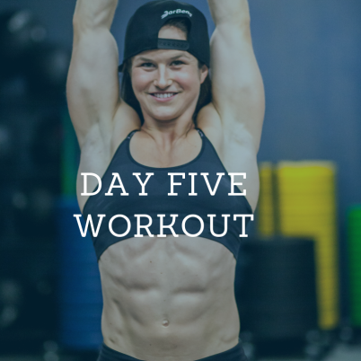
Lesson 5A: The Workout
3 Rounds - One Movement At A Time For The Time Listed

Level 1
:20on/ :10off
Hollow Rocks
Arch Rocks
Rest 1:00 then
6 MIN AMRAP
6 Burpees
12 Reverse Crunches with a Twist (6 each)
18 Alternating Tuck Up (9 each)
Level 2
:30 of each back and forth
Hollow Rocks
Arch Rocks
Rest 1:00 then
6 MIN AMRAP
6 Burpees
12 Reverse Crunches with a Twist (6 each)
18 Walking V-Ups (9 each)

Disclaimer:
As with all exercise programs, when using our exercise videos, you need to use common sense. To reduce and avoid injury, you will want to check with your doctor before beginning any fitness program.

By performing any fitness exercises, you are performing them at your own risk. PearcePointers, Kari Pearce, and M. Gordon Publishing Group, Inc, will not be responsible or liable for any injury or harm you sustain as a result of our fitness program, DVD, online fitness videos, or information shared on our website. This includes emails, videos and text.

Thanks for your understanding.

